**ActionBar**

Исходный код проекта:

[https://github.com/verkhoumov/AndroidLabs/tree/master/ActionBar](https://github.com/verkhoumov/AndroidLabs/tree/master/CallIntent)

Скриншоты экрана:

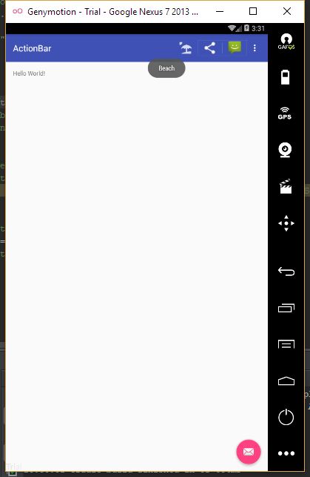

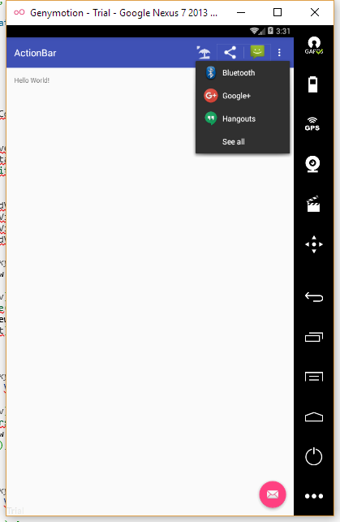

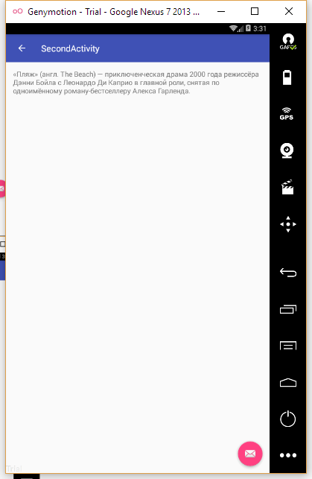

Исходный код.

MainActivity.java:

1. **package** ru.verkhoumov.actionbar;
3. **import** android.content.Intent;
4. **import** android.os.Bundle;
5. **import** android.support.design.widget.FloatingActionButton;
6. **import** android.support.design.widget.Snackbar;
7. **import** android.support.v4.view.MenuItemCompat;
8. **import** android.support.v7.app.AppCompatActivity;
9. **import** android.support.v7.widget.ShareActionProvider;
10. **import** android.support.v7.widget.Toolbar;
11. **import** android.view.View;
12. **import** android.view.Menu;
13. **import** android.view.MenuItem;
15. **public** **class** MainActivity **extends** AppCompatActivity {
16. **private** ShareActionProvider mShareActionProvider;
18. @Override
19. **protected** **void** onCreate(Bundle savedInstanceState) {
20. **super**.onCreate(savedInstanceState);
21. setContentView(R.layout.activity_main);
22. Toolbar toolbar = (Toolbar) findViewById(R.id.toolbar);
23. setSupportActionBar(toolbar);
25. FloatingActionButton fab = (FloatingActionButton) findViewById(R.id.fab);
26. fab.setOnClickListener(**new** View.OnClickListener() {
27. @Override
28. **public** **void** onClick(View view) {
29. Snackbar.make(view, "Replace with your own action", Snackbar.LENGTH_LONG)
30. .setAction("Action", **null**).show();
31. }
32. });
33. }
35. @Override
36. **public** **boolean** onCreateOptionsMenu(Menu menu) {
37. *// Заполнение меню. Все имеющиеся элементы добавляются на панель действий.*
38. getMenuInflater().inflate(R.menu.menu_main, menu);
40. MenuItem item = menu.findItem(R.id.action_share);
41. mShareActionProvider = (ShareActionProvider) MenuItemCompat.getActionProvider(item);
42. setIntent("Отправим шаблон сообщения");
44. **return** **super**.onCreateOptionsMenu(menu);
45. }
47. @Override
48. **public** **boolean** onOptionsItemSelected(MenuItem item) {
49. **switch** (item.getItemId()) {
50. **case** R.id.action_beach:
51. Intent intent = **new** Intent(**this**, SecondActivity.**class**);
52. startActivity(intent);
53. **return** **true**;
54. **case** R.id.action_settings:
55. **return** **true**;
56. **default**:
57. **return** **super**.onOptionsItemSelected(item);
58. }
59. }
61. **private** **void** setIntent(String text) {
62. Intent intent = **new** Intent(Intent.ACTION_SEND);
63. intent.setType("text/plain");
64. intent.putExtra(Intent.EXTRA_TEXT, text);
65. mShareActionProvider.setShareIntent(intent);
66. }
67. }

SecondActivity.java:

1. **package** ru.verkhoumov.actionbar;
3. **import** android.os.Bundle;
4. **import** android.support.design.widget.FloatingActionButton;
5. **import** android.support.design.widget.Snackbar;
6. **import** android.support.v7.app.AppCompatActivity;
7. **import** android.support.v7.widget.Toolbar;
8. **import** android.view.View;
10. **public** **class** SecondActivity **extends** AppCompatActivity {
12. @Override
13. **protected** **void** onCreate(Bundle savedInstanceState) {
14. **super**.onCreate(savedInstanceState);
15. setContentView(R.layout.activity_second);
16. Toolbar toolbar = (Toolbar) findViewById(R.id.toolbar);
17. setSupportActionBar(toolbar);
19. FloatingActionButton fab = (FloatingActionButton) findViewById(R.id.fab);
20. fab.setOnClickListener(**new** View.OnClickListener() {
21. @Override
22. **public** **void** onClick(View view) {
23. Snackbar.make(view, "Replace with your own action", Snackbar.LENGTH_LONG)
24. .setAction("Action", **null**).show();
25. }
26. });
27. getSupportActionBar().setDisplayHomeAsUpEnabled(**true**);
28. }
30. }

content_main.xml:

1. **<?xml** version="1.0" encoding="utf-8"**?>**
2. **<RelativeLayout** xmlns:android="http://schemas.android.com/apk/res/android"
3. xmlns:app="http://schemas.android.com/apk/res-auto"
4. xmlns:tools="http://schemas.android.com/tools"
5. android:layout_width="match_parent"
6. android:layout_height="match_parent"
7. android:paddingBottom="@dimen/activity_vertical_margin"
8. android:paddingLeft="@dimen/activity_horizontal_margin"
9. android:paddingRight="@dimen/activity_horizontal_margin"
10. android:paddingTop="@dimen/activity_vertical_margin"
11. app:layout_behavior="@string/appbar_scrolling_view_behavior"
12. tools:context="ru.verkhoumov.actionbar.MainActivity"
13. tools:showIn="@layout/activity_main"**>**
15. **<TextView**
16. android:layout_width="wrap_content"
17. android:layout_height="wrap_content"
18. android:text="Hello World!" **/>**
19. **</RelativeLayout>**

content_second.xml:

1. **<?xml** version="1.0" encoding="utf-8"**?>**
2. **<RelativeLayout** xmlns:android="http://schemas.android.com/apk/res/android"
3. xmlns:app="http://schemas.android.com/apk/res-auto"
4. xmlns:tools="http://schemas.android.com/tools"
5. android:layout_width="match_parent"
6. android:layout_height="match_parent"
7. android:paddingBottom="@dimen/activity_vertical_margin"
8. android:paddingLeft="@dimen/activity_horizontal_margin"
9. android:paddingRight="@dimen/activity_horizontal_margin"
10. android:paddingTop="@dimen/activity_vertical_margin"
11. app:layout_behavior="@string/appbar_scrolling_view_behavior"
12. tools:context="ru.verkhoumov.actionbar.SecondActivity"
13. tools:showIn="@layout/activity_second"**>**
15. **<TextView**
16. android:layout_width="wrap_content"
17. android:layout_height="wrap_content"
18. android:text="@string/the_beach_2000"
19. android:id="@+id/textView"
20. android:textSize="16dp"
21. android:layout_alignParentTop="true"
22. android:layout_alignParentStart="true"
23. android:layout_alignParentEnd="true" **/>**
24. **</RelativeLayout>**

menu_main.xml:

1. **<menu** xmlns:android="http://schemas.android.com/apk/res/android"
2. xmlns:app="http://schemas.android.com/apk/res-auto"
3. xmlns:tools="http://schemas.android.com/tools"
4. tools:context="ru.verkhoumov.actionbar.MainActivity"**>**
6. **<item**
7. android:id="@+id/action_beach"
8. android:orderInCategory="1"
9. android:icon="@drawable/ic_beach"
10. android:title="@string/action_beach"
11. app:showAsAction="ifRoom" **/>**
13. **<item**
14. android:id="@+id/action_share"
15. android:title="@string/action_share"
16. android:orderInCategory="2"
17. app:showAsAction="ifRoom"
18. app:actionProviderClass="android.support.v7.widget.ShareActionProvider" **/>**
20. **<item**
21. android:id="@+id/action_settings"
22. android:orderInCategory="3"
23. android:title="@string/action_settings"
24. app:showAsAction="never" **/>**
25. **</menu>**

strings.xml:

1. **<resources>**
2. **<string** name="app_name"**>**ActionBar**</string>**
3. **<string** name="action_settings"**>**Settings**</string>**
4. **<string** name="action_beach"**>**Beach**</string>**
5. **<string** name="title_activity_second"**>**SecondActivity**</string>**
6. **<string** name="action_share"**>**Share**</string>**
7. **<string** name="the_beach_2000"**>**«Пляж» (англ. The Beach) — приключенческая драма 2000 года режиссёра Дэнни Бойла с Леонардо Ди Каприо в главной роли, снятая по одноимённому роману-бестселлеру Алекса Гарленда.**</string>**
8. **</resources>**